**34**

**The Nature of Light and  
the Principles of Ray Optics**

|  |
| --- |
| **CHAPTER OUTLINE** |

34.1 The Nature of Light

34.2 The Ray Approximation in Ray Optics

34.3 Analysis Model: Wave Under Reflection

34.4 Analysis Model: Wave Under Refraction

34.5 Huygens’s Principle

34.6 Dispersion

34.7 Total Internal Reflection

* An asterisk indicates a question or problem new to this edition.

|  |
| --- |
| **SOLUTIONS TO THINK-PAIR-SHARE AND ACTIVITIES** |

**\*TP 34.1 Conceptualize** In each case, we are looking at a simple refraction between the top sheet and the bottom sheet.

**Categorize** We model the laser beam using the *wave under refraction* model.

**Analyze** For case (i), apply Snell’s law:

 (1)

For case (ii), apply Snell’s law:

 (2)

For case (iii), apply Snell’s law:

 (3)

We now have three equations in three unknowns. Let’s try to solve them. Subtract Equation (3) from Equation (1):

 (4)

This is the same relationship between *n*3 and *n*2 as given in Equation (2). No matter what we do with these three equations, we cannot solve them for the three indices of refraction.

**Finalize** While we have three equations in three unknowns, the equations are not *independent* equations. They all came from experiments performed in which the sheets were combined in pairs, so the resulting equations are mixtures of the effects of the individual sheets.]

*Answer:* no

**\*TP 34.2 Conceptualize** Figure 34.10a shows the path of the light as it enters the transparent material.

**Categorize** We use the *wave under refraction* model to describe the situation.

**Analyze** Because the light enters the water from air, we use *n*1 = 1.00. Therefore, Equation 34.7 becomes

 (1)

Therefore, a graph of the sine of the refracted angle against the sine of the incident angle should be a straight line and the slope of the line should be the reciprocal of the index of refraction of the material. That graph appears below.

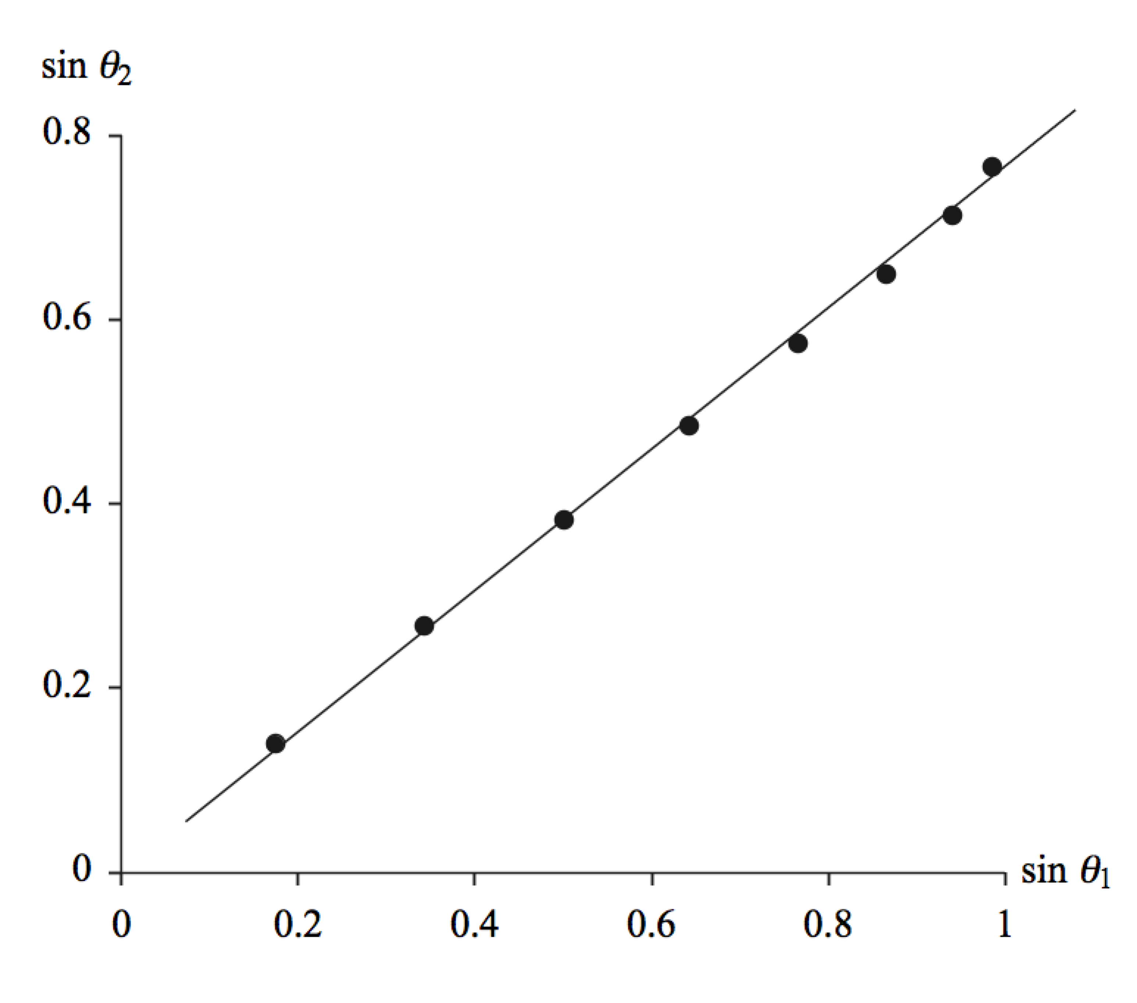

Evaluating the slope of this graph gives

Slope = 0.754

Taking the reciprocal of this result gives

*n*2 = 1.33

**Finalize** While this result could have been obtained from a single data point, finding it from the graph includes all of the data and reduces the uncertainty. Ptolemy’s data gives an index of refraction that agrees with the value we use almost two thousand years later!]

Answer: 1.33

|  |
| --- |
| **SOLUTIONS TO END-OF-CHAPTER PROBLEMS** |

Section 34.1 The Nature of Light

P34.1 The experiment is most convincing if the wheel turns fast enough to pass outgoing light through one notch and returning light through the next. This requires , or



so 

The returning light would be blocked by a tooth at one-half the angular speed, giving another data point.

P34.2 (a) The Moon’s radius is 1.74 × 106 m and the Earth’s radius is 6.37 × 106 m. The total distance traveled by the light is:



This takes 2.51 s, so



(b) The sizes of the objects need to be taken into account. Otherwise the answer would be too large by 2%.

P34.3 The difference is due to the extra time light takes to cross Earth’s orbit. From  we have



Section 34.3 The Ray Approximation in Ray Optics

**P34.4** (a) Let *AB* be the originally horizontal ceiling, *BC* its originally vertical normal, *AD* the new ceiling, and *DE* its normal. Then angle *BAD* = *φ*. By definition *DE* is perpendicular to *AD* and *BC* is perpendicular to *AB*. Then the angle between *DE* extended and *BC* is *φ* because angles are equal when their sides are perpendicular, right side to right side and left side to left side.

(b) Now *CBE* = *φ* is the angle of incidence of the vertical light beam. Its angle of reflection is also *φ*. The angle between the vertical incident beam and the reflected beam is 2*φ*.

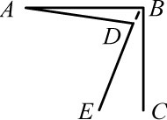

**ANS. FIG. P34.4(a)**

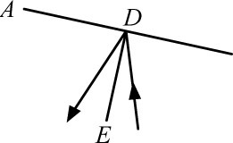

**ANS. FIG. P34.4(b)**

(c)  

**\*P34.5 Conceptualize** Review Example 34.2 to understand the situation.

**Categorize** We model the light beam as a *wave under reflection.*

**Analyze** From the geometry in the figure, we see that

 (1)

Substitute Equation (1) into the equation for ** given in the problem:

 (2)

**Finalize** Not only does the measuring device not interfere with the light beam for this new arrangement, but the expression for the deviation angle of the light is simpler!]

*Answer:* ** = 2**

**P34.6** ANS. FIG. P34.6 shows the path of the light ray.  and  are angles of incidence at mirrors 1 and 2.



**ANS. FIG. P34.6**

For triangle *abca*,



or  **[1]**

Now for triangle *bcdb*,



or  **[2]**

Substituting equation [2] into equation [1] gives 

Note: From equation [2],  Thus, the ray will follow a path like that shown only if  For   is negative and multiple reflections from each mirror will occur before the incident and reflected rays intersect.

**P34.7** (a) From geometry,

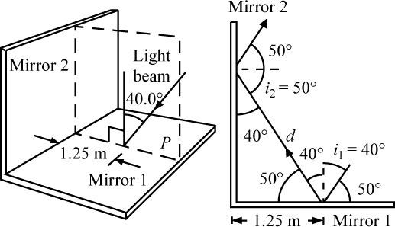

**ANS. FIG. P34.7**

1.25 m = *d* sin 40.0°

so 

(b) 

or parallel to the incident ray.

P34.8 (a) **Method One:**

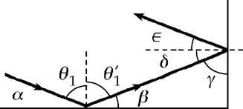

**ANS. FIG. P34.8**

The incident ray makes angle  with the first mirror. In ANS. FIG. P34.8, the law of reflection implies that 

Then,



In the triangle made by the mirrors and the ray passing between them,



Further, 

and 

Thus the final ray makes the same angle with the first mirror as did the incident ray. Its direction is opposite to the incident ray.

**Method Two:**

The vector velocity of the incident light has a component *vy* perpendicular to the first mirror and a component *vx* perpendicular to the second. The *vy* component is reversed upon the first reflection, which leaves *vx* unchanged. The second reflection reverses *vx* and leaves *vy* unchanged. The doubly reflected ray then has velocity opposite to the incident ray.

(b) 

Section 34.4 Analysis Model: Wave Under Refraction

P34.9 (a) flint glass: 

(b) water: 

(c) cubic zirconia: 

**P34.10** At entry, the wave under refraction model, expressed as   
 , gives



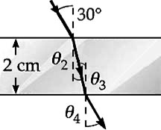

**ANS. FIG. P34.10**

To do ray optics, you must remember some geometry. The surfaces of entry and exit are parallel so their normals are parallel. Then angle  of refraction at entry and the angle  of incidence at exit are alternate interior angles formed by the ray as a transversal cutting parallel lines. Therefore, 

At the exit point,  gives



Because  and  are equal, the departing ray in air is parallel to the original ray.

P34.11 From Snell’s law, . Thus, when  and the first medium is air (*n*1 = 1.00), we have .

(a) For quartz, *n*2 = 1.458: 

(b) For carbon disulfide, *n*2 = 1.628: 

(c) For water, *n*2 = 1.333: 

P34.12 (a) The law of refraction    
can be put into the more general form

**ANS. FIG. P34.12**

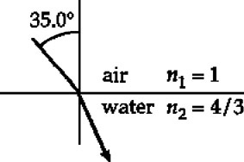



This is equivalent to Equation 34.2. This form applies to all kinds of waves that move through space.

In air at 20°C, the speed of sound is 343 m/s. From Table 17.1, the speed of sound in water at 25.0°C is 1493 m/s. The angle of incidence is 13.0°:



(b) The wave keeps constant frequency in all media:



(c) Using Snell’s law,



(d) 

(e) 

**P34.13** (a) 



(c)  in air and in syrup.

(d) 

(b) 

**P34.14** (a) The angle of incidence at the first surface is  and the angle of refraction is



Also, 

Therefore, the angle of incidence at the second surface is  The angle of refraction at this surface is



ANS. FIG. P34.14 traces the path of the ray of light.

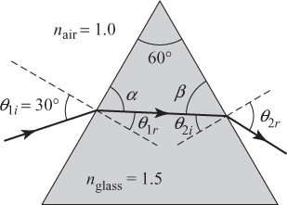

**ANS. FIG. P34.14**

(b) The angle of reflection at each surface equals the angle of incidence at that surface. Thus,



**P34.15** Consider glass with an index of refraction of 1.50, which is 3.00 mm thick. The speed of light in the glass is



The extra travel time is



For light of wavelength 600 nm in vacuum and wavelength  in glass, the extra optical path, in wavelengths, is



**P34.16** Refraction proceeds according to

 **[1]**

(a) For the normal component of velocity to be constant,

 or  **[2]**

We multiply equations [1] and [2], obtaining:

 or 

We do not consider the case . The physical solution is

 or 

Then equation [1] becomes:





(b) 

**\*P34.17 Conceptualize** Let’s draw a ray diagram for the situation to understand what’s going on:

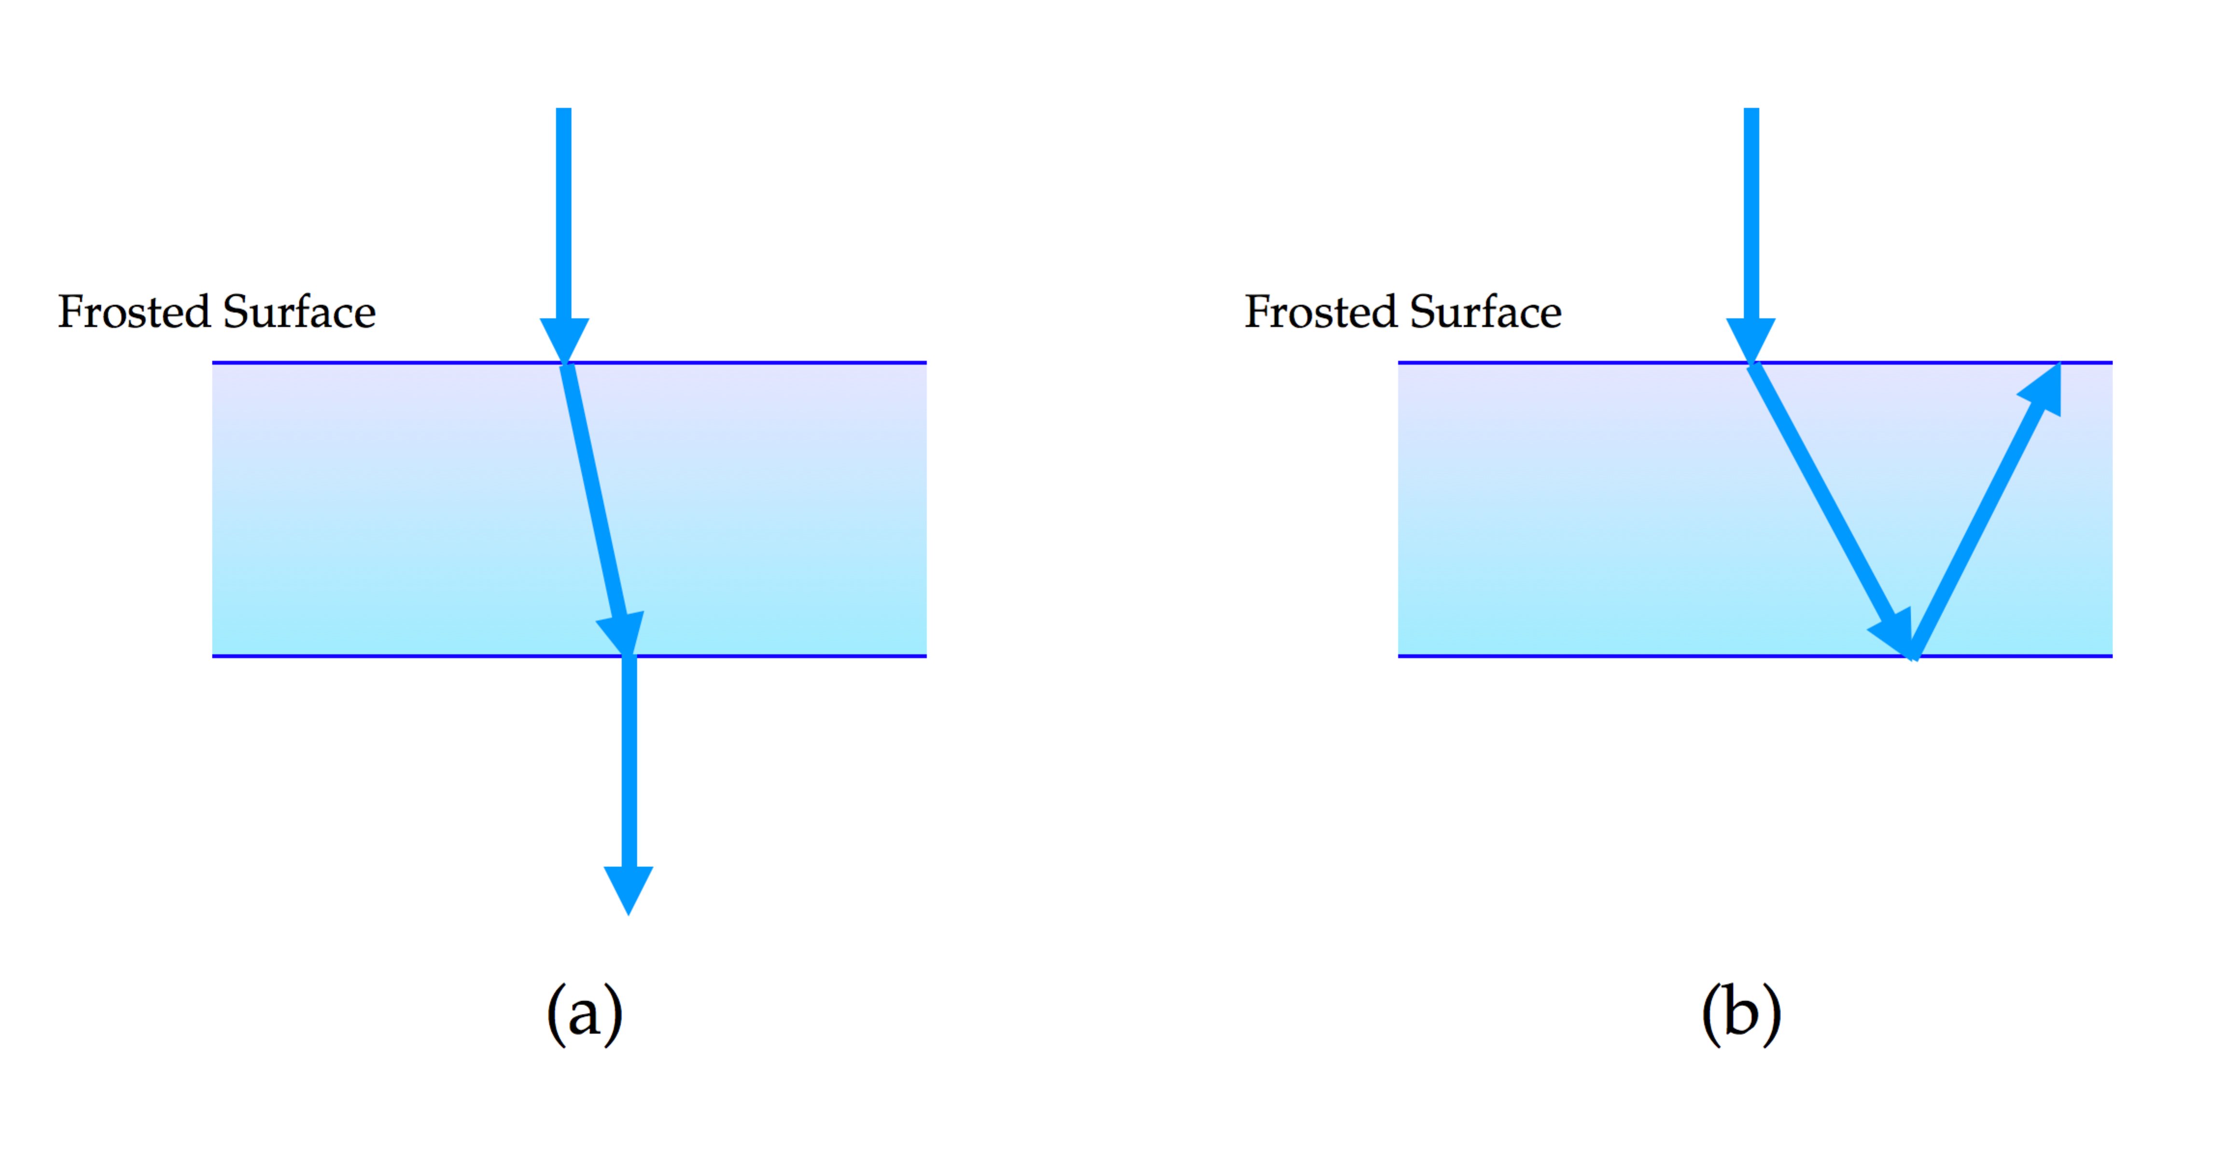

In the diagram, we see a beam of light coming down from the laser pointer and striking the frosted surface at normal incidence. The light entering the glass will scatter in all directions due to the frosting. If the direction involves a small angle relative to the normal, as in part (a) of the diagram, most of the light will strike the back surface of the glass and refract into the shower. Some light will reflect from this surface, but only a small fraction of that which refracts. These types of rays are responsible for the dark ring around the central reflection. In part (b) of the diagram, we look at light scattered by the frosting that enters the glass at a large angle relative to the normal. For large enough angles, the light striking the back surface of the glass will be incident at an angle larger than the critical angle for total internal reflection. As a result, *all* of the light incident on the back surface will reflect back to the frosted surface, at which point it is scattered out into the room, resulting in the halo that is seen.

**Categorize** We use the *wave under reflection* model, the *wave under refraction* model, and the special case of total internal reflection.

**Analyze** Let us look at the situation in which the scattered light strikes the back surface of the glass at the critical angle:

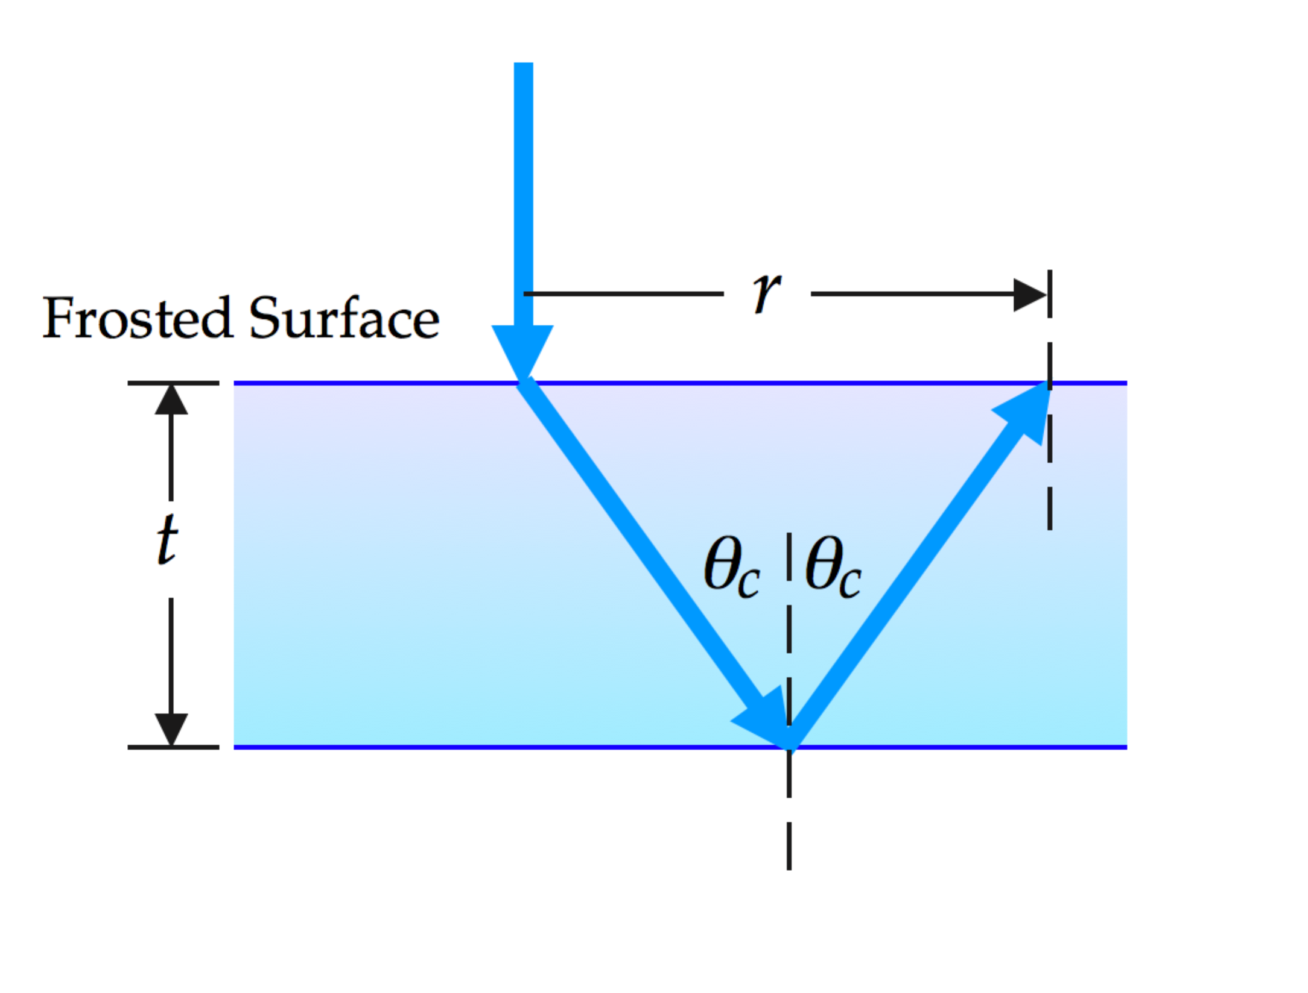

From the geometry of the light rays, we see that

 (1)

From Equation 34.9, we know that the critical angle at the back surface of the glass satisfies the equation

 (2)

Combine Equations (1) and (2) and solve for the index of refraction of the glass:

 (3)

Simplify the expression by imagining a right triangle with an angle *c* whose legs are such that Equation (1) is satisfied:

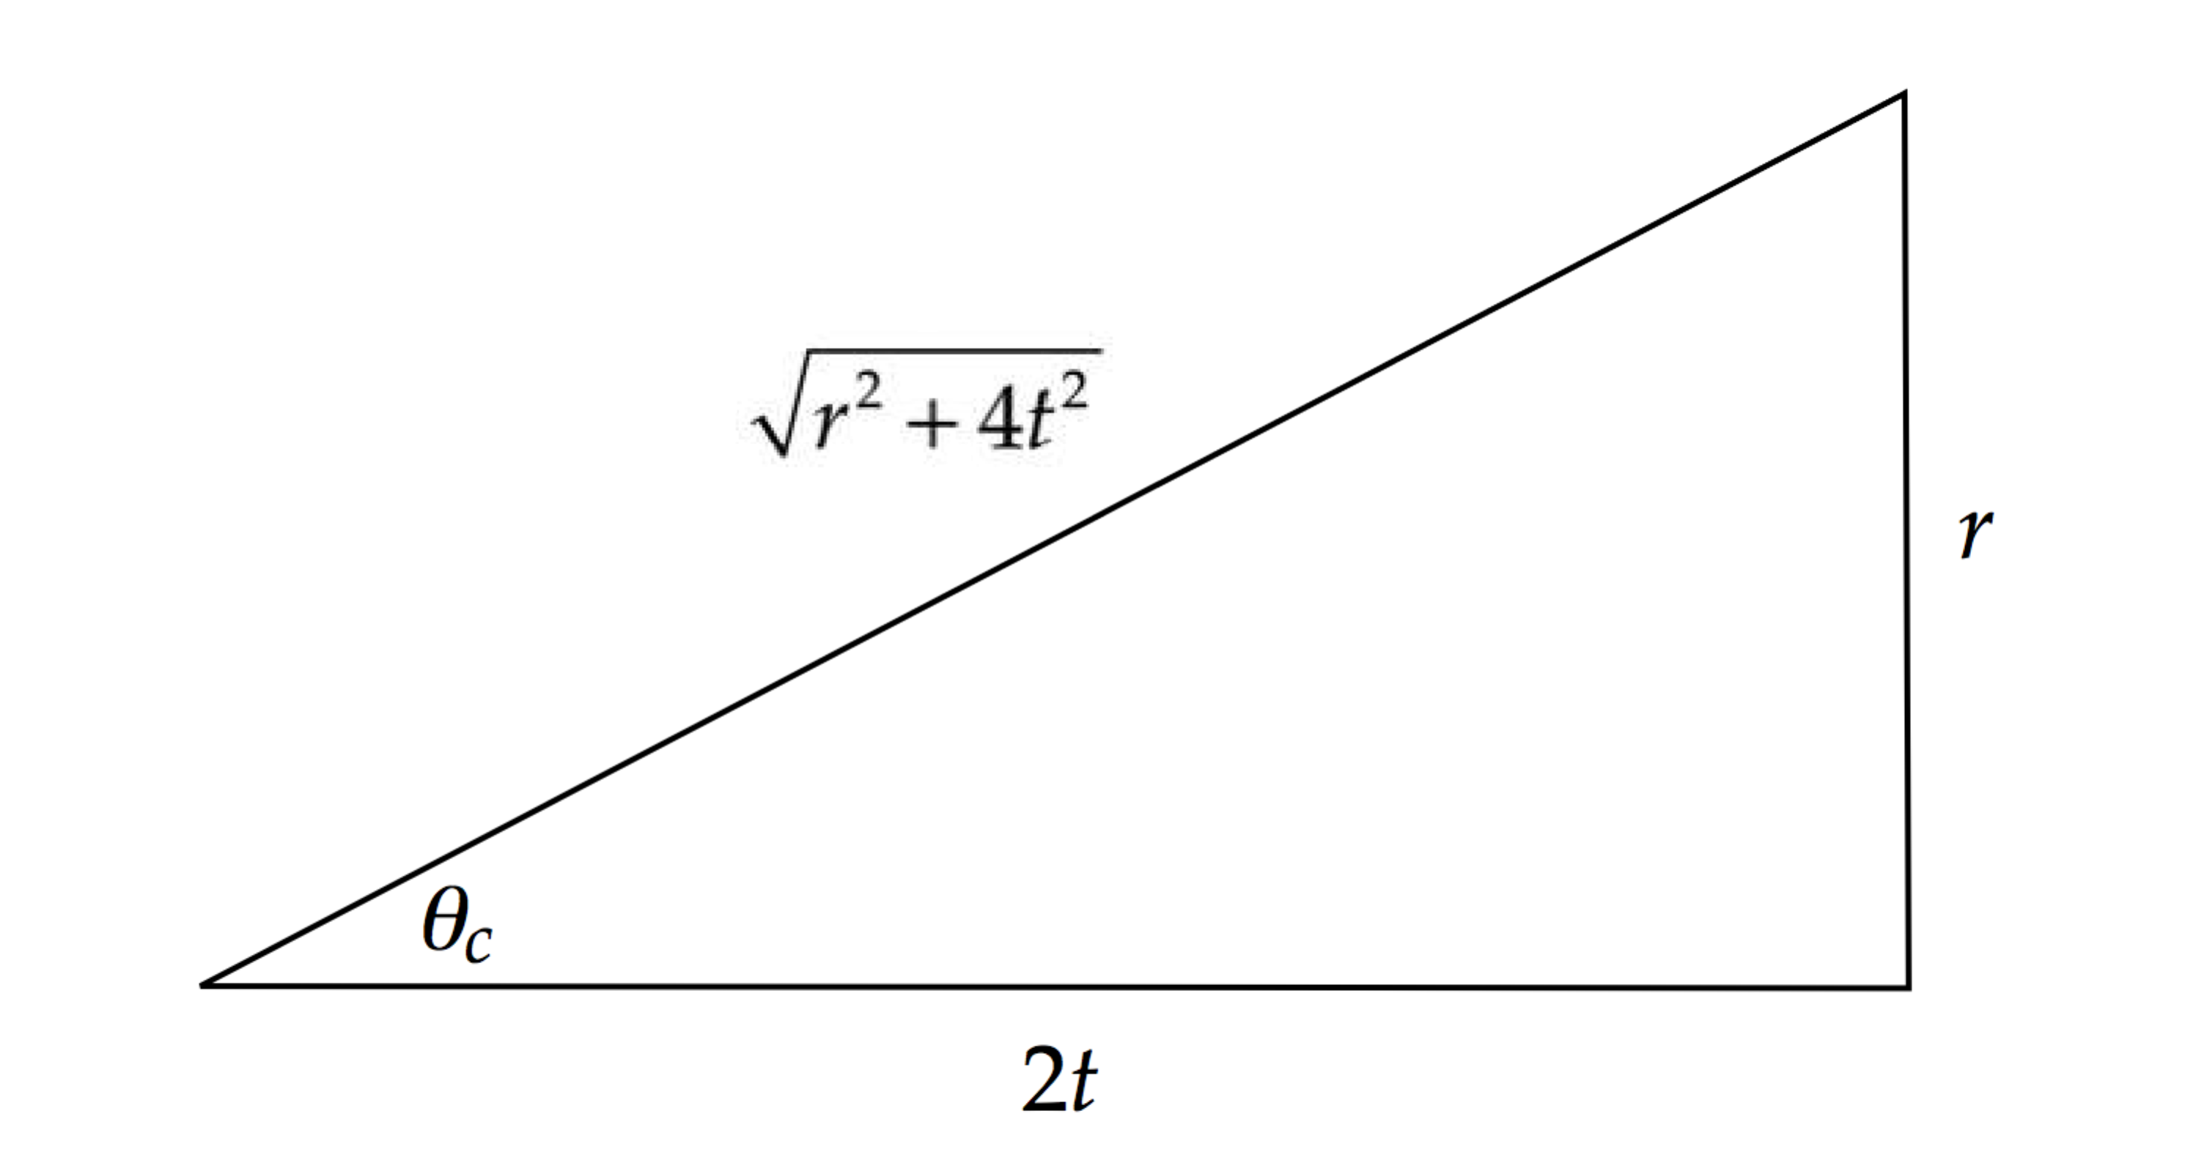

Then Equation (3) becomes

 (4)

Substitute numerical values:



**Finalize** Verify that Equation (3) gives the same numerical result as Equation (4).]

*Answer: n* = 1.55

**P34.18** Note for use in every part (refer to ANS. FIG. P34.18): from apex angle ,



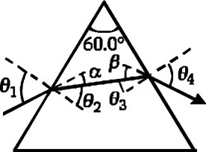

**ANS. FIG. P34.18**

so 

At the first surface the deviation is



At exit, the deviation is



The total deviation is therefore



(a) At entry,

 or 

Thus, 

At exit,



or 

so the path through the prism is symmetric when .

(b) 

(c) At entry,





At exit,





(d) At entry,





At exit,





**\*P34.19 Conceptualize** The important consideration here is the light ray from the Sun that just misses the top of the flag pole and travels toward the water. This ray then refracts into the water and strikes the bottom of the pool, defining the top edge of the shadow of the flag pole.

**Categorize** We model the ray described in Conceptualize as a *wave under refraction*.

**Analyze** (a) Let us set the geometry according to the diagram below:

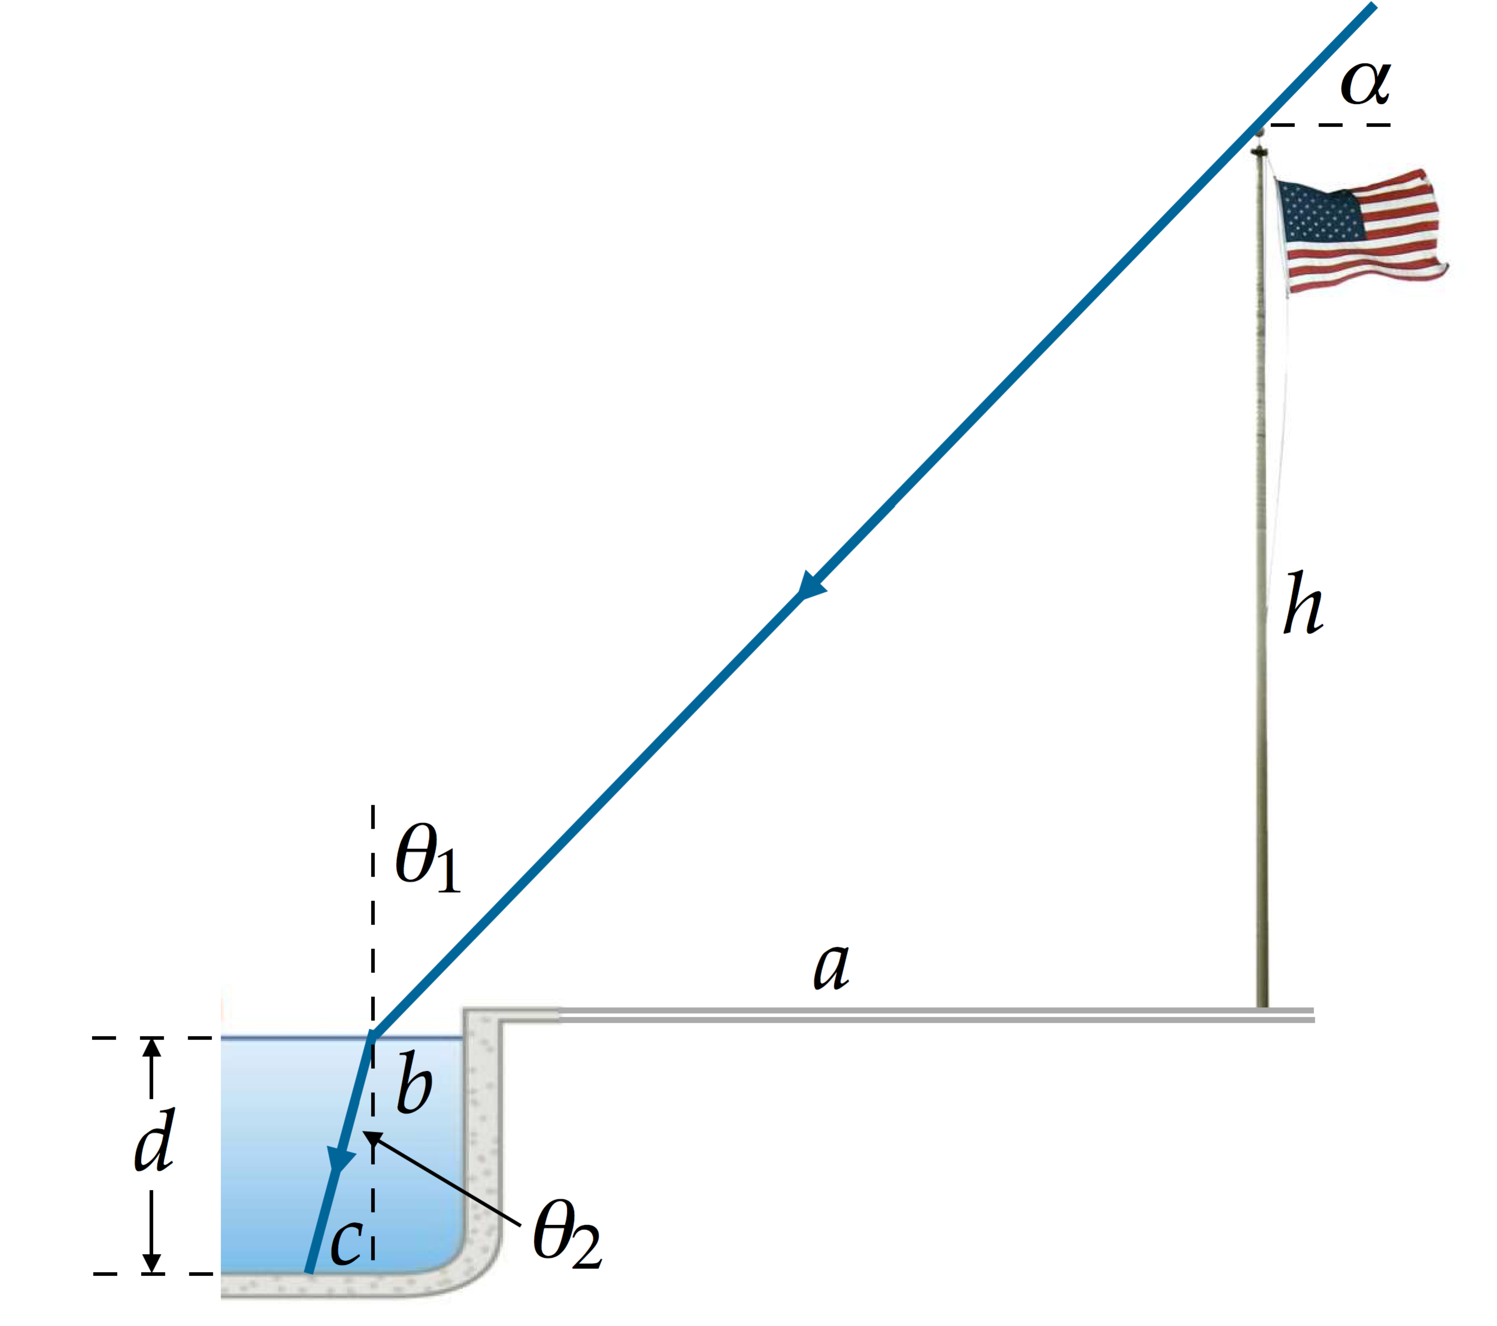

The height of the flag pole above the ground is *h* and the angle of a ray from the Sun is ** relative to the horizontal. The distance *a* is from the edge of the pool to the flag pole. The distance *b* is from the edge of the pool to the point at which the light ray that just misses the top of the flag pole enters the water. The water is of depth *d*. The distance *c* is from where the normal to the water at the surface intersects with the bottom of the pool to where the light ray strikes the bottom of the pool.

Given this geometry, the distance of the shadow of the tip of the flag pole on the bottom of the pool from the south wall of the pool is

 (1)

From the geometry of the triangle whose hypotenuse is the light ray *under* the water, we see that

 (2)

From the geometry of the triangle whose hypotenuse is the light ray *above* the water, we see that

 (3)

Substitute Equations (2) and (3) into Equation (1):

 (4)

The angle **2 in Equation (4) is related to the angle **1 in the diagram by Snell’s law:

 (5)

The angle at which the light ray strikes the water is **, so

 (6)

Substitute Equation (6) into Equation (5):

 (7)

Substitute Equation (7) into Equation (4):

 (8)

Substitute numerical values:



(b) In order not to have a shadow on the bottom of the pool, the light ray from the top of the pole must strike the edge of the pool but not enter the water. Therefore, the horizontal leg of the triangle whose hypotenuse is the light ray *above* the water is *a*. Therefore, there will be no shadow for



Because the Sun reaches 68.5° at the summer solstice, there will indeed be a few days around the summer solstice on which no shadow will be cast on the bottom of the pool.

**Finalize** You might have been tempted to set  = 0 in Equation (8) to solve part (b) of the problem. This would have led to a very messy equation to solve for the angle **, and the answer would have been **incorrect** anyway. Nowhere in the equations did you enter in the fact that there is an opaque corner that can block light at the south edge of the pool. Therefore, if you set  = 0 in Equation (8), you are solving a problem in which there is water to the right of the actual edge of the pool. By keeping sight of the real situation and realizing that the light will hit the edge of the pool, the problem becomes (1) correct and (2) easy, as shown above!]

*Answer:* (a) 1.67 m (b) yes

**P34.20** (a) Before the container is filled, the   
ray’s path is as shown in ANS.   
FIG. P34.20 (a). From this figure,   
observe that

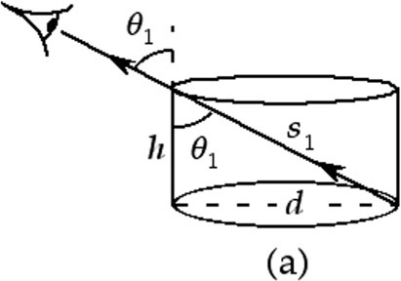

**ANS. FIG. P34.20 (a)**



After the container is filled, the   
ray’s path is shown in ANS. FIG.   
P34.20 (b). From this figure, we find that



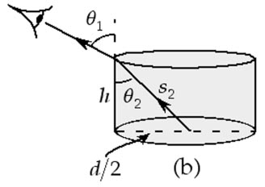

**ANS. FIG. P34.20(b)**

From Snell’s law, we have



(b) For water, *n* = 1.333.



(c) 

P34.21 

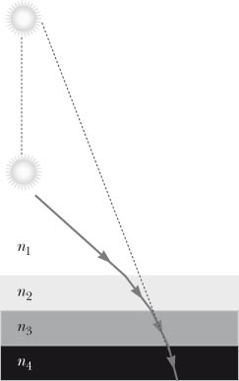

**ANS. FIG. P34.21**

P34.22 (a) A sketch illustrating the situation and the two triangles needed in the solution is given in ANS. FIG. P34.22.

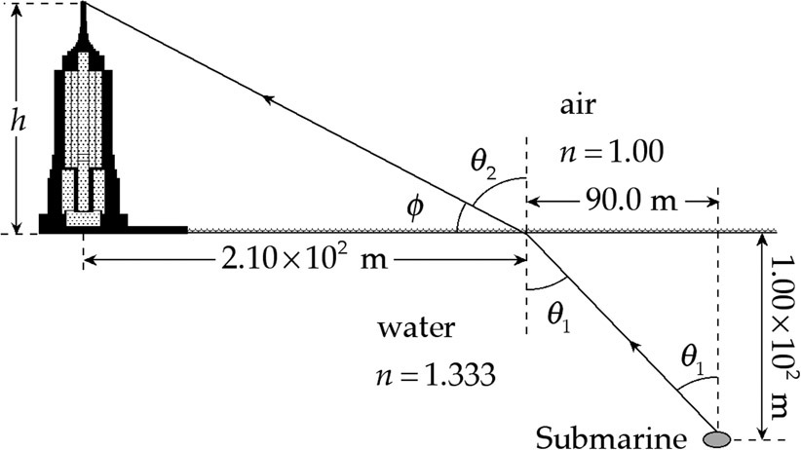

**ANS. FIG. P34.22**

(b) From the triangle under water, the angle of incidence  at the water surface is



(c) Snell’s law gives the angle of refraction as



(d) The refracted beam makes angle  with the horizontal.

(e) In the triangle above the water,

 

P34.23 The reflected ray and refracted ray are perpendicular to each other, and the angle of reflection  and the angle of refraction  are related by



Then, from Snell’s law,



Thus,  or 

Section 34.6 Dispersion

P34.24 Using Snell’s law gives



and 

Thus, the dispersion is 

**P34.25** For the incoming ray, 

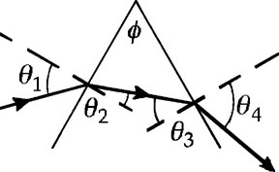

**ANS. FIG. P34.25**

Using ANS. FIG. P34.25,



For the outgoing ray,



and

: 

The angular dispersion is the difference



P34.26 Recall that if a wave slows down as it passes from one medium into another, its rays tend to bend toward the normal, unless it has normal incidence. Example: the case when light passes from air into water.

(a) For the diagrams of contour lines and wave fronts and rays, see ANS. FIG. P34.26 (a) below.

(b) As the waves move to shallower water, the wave fronts slow down, and those closer to shore slow down more. The rays tend to bend toward the normal of the contour lines; or equivalently, the wave fronts bend to become more nearly parallel to the contour lines. See ANS. FIG. P34.26 (b) below.

(c) For the diagrams of contour lines and wave fronts and rays, see ANS. FIG. P34.26 (c) below.

(d) We suppose that the headlands are steep underwater, as they are above water. The rays are everywhere perpendicular to the wave fronts of the incoming refracting waves. As shown, because the rays tend to bend toward the normal of the contour lines, the rays bend toward the headlands and deliver more energy per length at the headlands. See ANS. FIG. P34.26 (d) below.

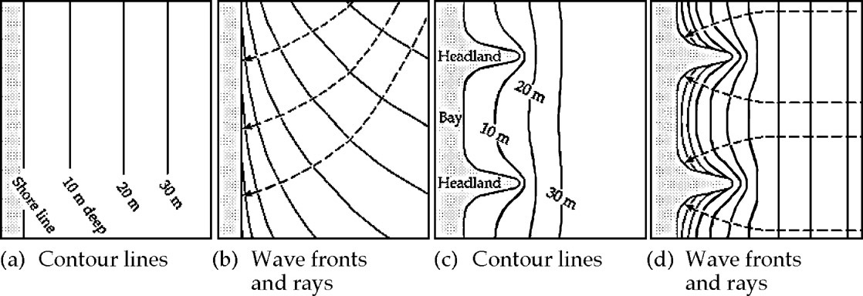

**ANS. FIG. P34.26**

Section 34.7 Total Internal Reflection

P34.27 From Equation 34.9,  where *n*2 = 1.000 293. Values for *n*1 come from Table 34.1,

(a) 

(b) 

(c) 

P34.28 (a) Using the index of refraction values listed in Table 34.1, we find



(b) 

(c) 

(d) The angle of incidence is 34.0°. Yes. In this case, the angle of incidence is just larger than the critical angle, so the light ray again undergoes total internal reflection at *P*.

(e) The angle of incidence must be reduced below the critical angle for light to exit the diamond, so the diamond should be rotated clockwise.

(f) Rotating the diamond by angle *θ* clockwise changes the angle of incidence  at point *A* from 0.00° to *θ*, causing the angle of refraction  inside the diamond to change from 0.00°:



Refer to ANS. FIG. P34.28. What is the angle of incidence at *P*? Extending a line from points *A* and *P* parallel to the surfaces of the diamond until they meet at point *B*, we form a triangle *ABP*.

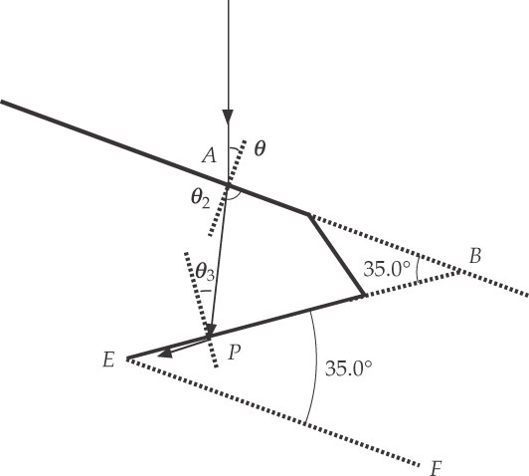

**ANS. FIG. P34.28**

The angle at vertex *B* is 34.0° because the extended line *AB* is parallel to the line *EF* extended from the base of the diamond. From the sum of the interior angles of *ABP*, we find the incident angle  at point *P*:



At *P*, we require that the angle of incidence  results in an angle of refraction of 90.0°:



solving gives  Then, from above,



P34.29 (a)  and  at the critical angle.

 so 

(b) Sound can be totally reflected if it is traveling in the medium where it travels slower: 

(c)   
so the wall is a good mirror.

P34.30 (a) In the gasoline gauge, skylight from above travels down the plastic. The rays close to the vertical are totally reflected from the sides of the slab and from both facets at the lower end of the plastic, where it is not immersed in gasoline. This light returns up inside the plastic and makes it look bright. Where the plastic is immersed in gasoline, with index of refraction of about 1.50, total internal reflection should not happen. The light passes out of the lower end of the plastic with little reflected, making this part of the gauge look dark.

(b) To ensure total internal reflection at the plastic-air interface, the critical angle must be less than the angle of incidence, about 45.0°. This places a lower limit on the index of refraction of the plastic:



To prevent total internal reflection at the plastic-gasoline interface, the critical angle must be greater than the angle of incidence. This places an upper limit on the index of refraction of the plastic:



**P34.31** (a) If any ray escapes it will be a ray along the inner edge, because it has the smallest angle of incidence. Its angle of incidence is described by  and by  Then



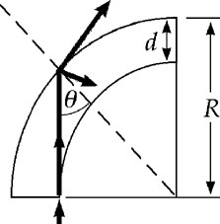

**ANS. FIG. P34.31**

(b) As , . Yes: for very small *d*, the light strikes the interface at very large angles of incidence.

(c) As *n* increases, *R*min decreases. Yes: as *n* increases, the critical angle becomes smaller.

(d) As *n* decreases toward 1, *R*min increases. . Yes: as , the critical angle becomes close to 90° and any bend will allow the light to escape.

(e) 

**Additional Problems**

**P34.32** (a) 

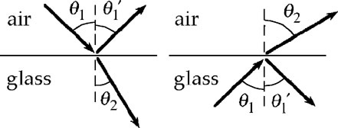

**ANS. FIG. P34.32**





(b) 



(c), (d) The other entries are computed similarly, and are shown in Table P34.32 below.

|  |  |  |  |  |  |
| --- | --- | --- | --- | --- | --- |
| (c) air into glass, angles in degrees | | | (d) glass into air, angles in degrees | | |
| incidence | reflection | refraction | incidence | reflection | refraction |
| 0 | 0 | 0 | 0 | 0 | 0 |
| 10.0 | 10.0 | 6.43 | 10.0 | 10.0 | 15.6 |
| 20.0 | 20.0 | 12.7 | 20.0 | 20.0 | 32.0 |
| 30.0 | 30.0 | 18.8 | 30.0 | 30.0 | 50.8 |
| 40.0 | 40.0 | 24.5 | 40.0 | 40.0 | 85.1 |
| 50.0 | 50.0 | 29.6 | 50.0 | 50.0 | none* |
| 60.0 | 60.0 | 34.0 | 60.0 | 60.0 | none* |
| 70.0 | 70.0 | 37.3 | 70.0 | 70.0 | none* |
| 80.0 | 80.0 | 39.4 | 80.0 | 80.0 | none* |
| 90.0 | 90.0 | 40.2 | 90.0 | 90.0 | none* |

*total internal reflection

**TABLE P34.32**

**P34.33** The incident light reaches the left-hand mirror at distance



above its bottom edge. The reflected light first reaches the right-hand mirror at height



**ANS. FIG. P34.33**



It bounces between the mirrors with this distance between points of contact with either. Since



the light reflects



**\*P34.34** **Conceptualize** At each surface, the angles of incidence and refraction must satisfy Snell’s law. Do you think we’ll need Snell’s law to solve this problem?

**Categorize** This problem involve refraction of light in a prism, so we will expect to use the *waves under refraction* analysis model.

**Analysis** Let’s focus a little tighter on the sites of refraction:

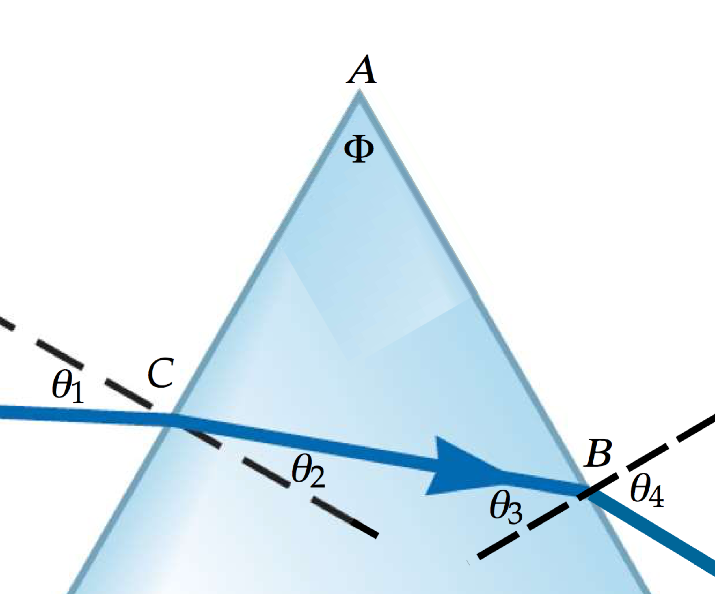

We have added three labels for points *A*, *B*, and *C*. Consider now the triangle *ABC*. The sums of the three angles in the triangle must add to 180°:



which is what we set out to prove.

**Finalize** Did we ever use Snell’s law? No! This suggests that what we have shown is a general geometric result.

Answer: See solution

P34.35 

P34.36 The number *N* of reflections the beam makes before exiting at the other end is equal to the length of the slab divided by the component of the displacement of the beam for each reflection:



where  is the refracted angle as the beam enters the material. Substitute for this refracted angle in terms of the incident angle by using Snell’s law:



Substitute numerical values:



Therefore, the beam will exit after making 81 reflections, so it does not make 85 reflections.

**P34.37** (a) The fraction reflected is



(b) If medium 1 is glass and medium 2 is air,



There is 

**P34.38** (a) With *n*1 = 1 and *n*2 = *n*, the reflected fractional intensity is



The remaining intensity must be transmitted:



(b) At entry, 

At exit, 

Overall, 

or 

P34.39 Let *n*(*x*) be the index of refraction at distance *x* below the top of the atmosphere and *n*(*x* = *h*) = 1.00 293 be its value at Earth’s surface. Then,



(a) The total time interval required to traverse the atmosphere is



(b) The travel time in the absence of an atmosphere would be  Thus, the time in the presence of an atmosphere is



P34.40 Let *n*(*x*) be the index of refraction at distance *x* below the top of the atmosphere and *n*(*x* = *h*) = *n* be its value at the planet surface.

Then, 

(a) The total time interval required to traverse the atmosphere is





(b) The travel time in the absence of an atmosphere would be . Thus, the time in the presence of an atmosphere is



**P34.41** From Table 34.1, the index of refraction of polystyrene is 1.49.

(a) For polystyrene *surrounded by air*, total internal reflection requires



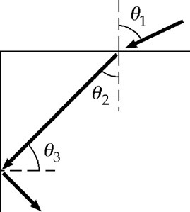

**ANS. FIG. P34.41**

Then from geometry, 

From Snell’s law,



Any angle  satisfies this equation.



(b) For polystyrene *surrounded by water*, 

and 

From Snell’s law, 

(c) From Table 34.1, the index of carbon disulfide is 1.628 > 1.49. Total internal reflection never occurs as the light moves from lower-index polystyrene into higher-index carbon disulfide.

P34.42 In ANS. FIG. P34.42, observe on the left side of the prism that  and  Thus,  Similarly, on the right side of the prism,  and , giving  The incident rays are initially parallel, so observe that the angle between the reflected rays is , so . Finally, observe that the left side of the prism is sloped at angle *α* from the vertical, and the right side is sloped at angle *ε*. The angle *φ* is related to the other angles by



Thus, we obtain the result



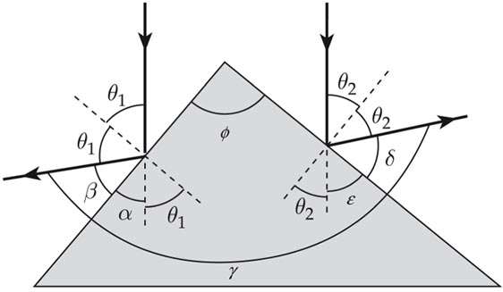

**ANS. FIG. P34.42**

**P34.43** Observe in ANS. FIG. P34.43 that the angle of incidence at point *P* is *γ*, and using triangle *OPQ*:

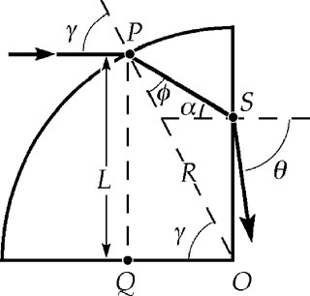

**ANS. FIG. P34.43**



Also, 

Apply Snell’s law at point *P*:



Thus, 

and 

From triangle *OPS*,  or the angle of incidence at point *S* is . Then, applying Snell’s law at point *S*

gives 

or 

thus, 

or, using from above  and ,





**P34.44** Consider an insulated box with the imagined one-way mirror forming one face, installed so that 90% of the electromagnetic radiation incident from the outside is transmitted to the inside and only a lower percentage of the electromagnetic waves from the inside make it through to the outside. Suppose the interior and exterior of the box are originally at the same temperature. Objects within and without are radiating and absorbing electromagnetic waves. They would all maintain constant temperature if the box had an open window. With the glass letting more energy in than out, the interior of the box will rise in temperature. But this is impossible, according to Clausius’s statement of the second law. This reduction to a contradiction proves that it is impossible for the one-way mirror to exist.

**P34.45** Applying Snell’s law at points A, B, and C gives

 **[1]**

 **[2]**

and  **[3]**

Combining equations [1], [2], and [3] yields

 **[4]**

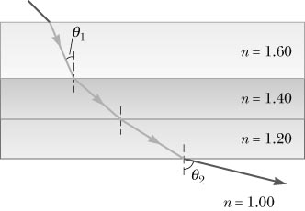

**ANS. FIG. P34.45**

Note that equation [4] is exactly what Snell’s law would yield if the second and third layers of this “sandwich” were ignored. This will always be true if the surfaces of all the layers are parallel to each other.

(a) If , then equation [4] gives



(b) At the critical angle of incidence on the lowest surface, . Then, equation [4] gives



Total internal reflection will occur for .

**P34.46** (a) The optical day is longer. Incoming sunlight is refracted downward at the top of the atmosphere, so an observer can see the rising Sun when it is still geometrically below the horizon. Light from the setting Sun reaches her after the Sun is below the horizon geometrically.

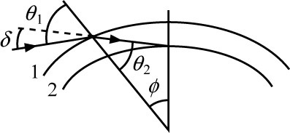

**ANS. FIG. P34.46**

(b) ANS. FIG. P34.46 illustrates optical sunrise. At the center of the Earth,



At the top of the atmosphere



Deviation upon entry is



Sunrise of the optical day is before geometric sunrise by  Optical sunset occurs later too, so the optical day is longer by 

P34.47  and  with *n*1 = 1, 

Thus, 

(You can use a calculator to home in on an approximate solution to this equation, testing different values of  until you find that  Alternatively, you can solve for  exactly, as shown below.)

We are given that 

This is the sine of a difference, so



Rearranging, 



and 

**\*P34.48 Conceptualize** Let us first simplify the problem significantly. At the left slanted edge, the light enters at normal incidence. Therefore, there is no dispersion in this first process. At the top surface, the light reflects. Therefore, there is no dispersion in this second process. The only refraction with non-normal incidence is at the right slanted surface, so that is the only place that there will be dispersion.

**Categorize** We model the light beam as both a *wave under reflection* and a *wave under refraction.*

**Analyze** (a) Let us add some geometry to the diagram based on our knowledge of right triangles:

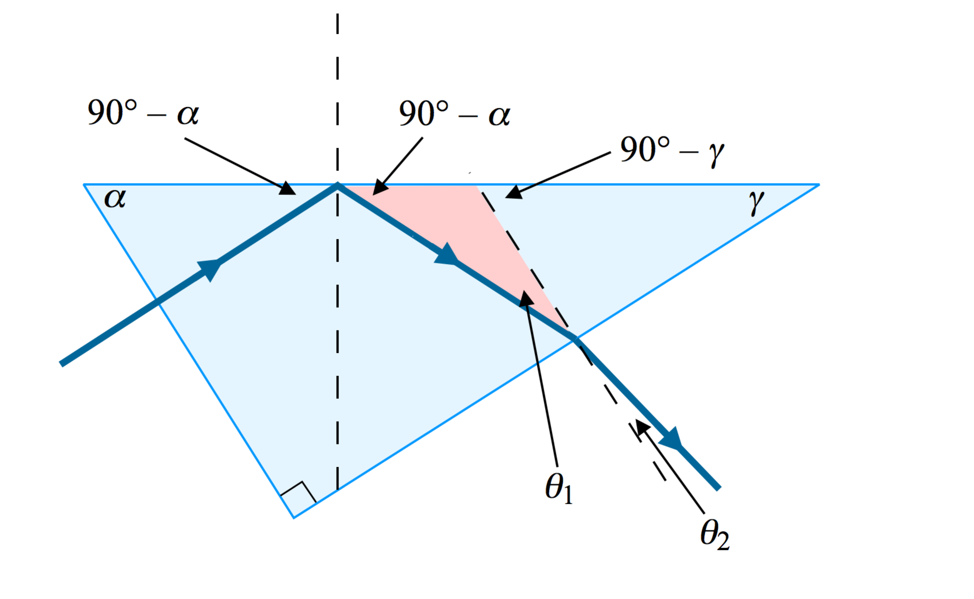

The angle 90° – ** at the upper left arises due to the right triangle formed by the light beam in the material as one leg and the section of the top surface from the left corner to the dashed normal line as the hypotenuse. The second angle 90° – ** above the top surface in the diagram arises from the law of reflection. The angle 90° – ** at the upper right arises due to the right triangle formed by the sections of the top surface and the right slanted surface down to the normal line perpendicular to the right slanted surface. The diagram also shows the angles **1 and **2 for the refraction at the right slanted surface.

Now, let’s write Snell’s law for the refraction at the right slanted surface:

 (1)

The range of angles due to dispersion requested by your supervisor corresponds to the range of values of **2. Solve Equation (1) for **2:

 (2)

where we have recognized that *n*2 = 1.00 for air and *n*1 = *n* for the material from which the prism is made. Now, the difference in the outgoing angle will be the difference in Equation (2) for different values of *n*:

 (3)

where *n*max and *n*min represent the upper and lower limits of the index of refraction over the visible range of wavelengths. Now, consider the non-right triangle shown in pink in the figure. Two of the angles in this triangle are 90° – ** and **1. The exterior angle for this triangle is 90° – **. Therefore, from the exterior angle theorem,

 (4)

Substitute Equation (4) into Equation (3):

 (5)

Equation (5) is the expression requested by your supervisor.

(b) Now, why doesn’t it work for the prism of cubic zirconia when the prism is actually built? Notice the argument of the inverse sine. The value of the sine of an angle is always less than or equal to 1.00. Therefore, we must have, for an arbitrary *n*,

 (6)

For a prism with ** = 60° and ** = 30°,

 (7)

Looking in Table 34.1, we find



Therefore the condition in Equation (7) is not satisfied for cubic zirconia. This same prism must be constructed of a different material, or the angles ** and ** must be altered to allow for the higher value of *n*.

**Finalize** We have seen what happens *mathematically* in the case of cubic zirconia. What happens *physically*? Equation (4) gives us the incident angle on the right slanted surface:



Now use Equation 34.9 to find the critical angle for cubic zirconia:



Therefore, the beam of light strikes the right slanted surface at an angle larger than the critical angle and is totally reflected. It may eventually exit the prism, but not via the simple path shown in the diagram.

To test Equation (5) a bit, what happens if ** = **? Equation (5) becomes



Does this make sense? Imagine ** = ** in the diagram. The prism then becomes an isosceles triangle with ** = ** = 45°. Then, by symmetry, we can argue that the beam strikes the right slanted surface at normal incidence. Therefore, there is no dispersion anywhere, consistent with the result above of ∆**2 = 0.

Let’s evaluate a typical value for the angular spread. Suppose we consider a prism made from crown glass with ** = 60° and ** = 30°. Then, using estimates from Figure 34.20 and Equation (5), we have



If you differentiate Equation (2) with respect to *n*, you obtain



For a small spread in the index of refraction, we can substitute *dn* = *n*max – *n*min, and interpret *n* as the average value of the index of refraction for the visible range. If you evaluate this expression for the crown glass example just completed, you obtain a result for *d*2 that is significantly different from what we found for ∆**2. Why? ]

*Answer:* (a)  (b) Index of refraction for cubic zirconia is too large to allow any refraction at the second surface.

**P34.49** (a) At the boundary of the air and glass, the critical angle is given by



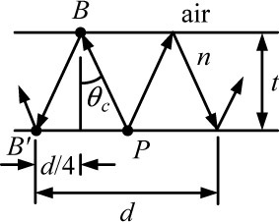

**ANS. FIG. P34.49**

Consider the critical ray *PBB*′:

 or 

Squaring the last equation gives:



Since , this becomes  or



(b) Solving for *d*,



Thus, if *n* = 1.52 and *t* = 0.600 cm, 

(c) Since violet light has a larger index of refraction, it will lead to a smaller critical angle and the inner edge of the white halo will be tinged with  light.

P34.50 Because the enclosure is square and the beam enters at bottom center, and because a light beam travels the same path regardless of its direction on the path, we expect the beam pattern to be symmetric about a vertical line passing through the opening. Therefore, the beam enters the opening at the same angle it exits, the beam strikes each side mirror at the same height, and the beam forms a zigzag pattern that intersects itself at a point (or points) above the center opening; thus, the beam must reflect off the top mirror at its center. Also, because of the law of reflection, the path of the beam is symmetric about a horizontal line passing through the points where the beam reflects off a side mirror.

(a) Call the length of each side of the square *L*. If the beam is to strike each mirror once, the beam must strike each side mirror at its center, at height *L*/2 after traveling a horizontal distance *L*/2. Therefore,



The beam will exit the enclosure if it enters at angle  as shown in ANS. FIG. P34.50 (a).

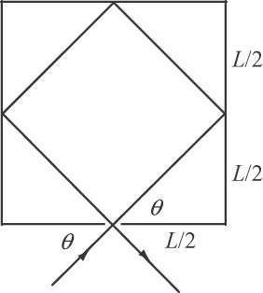 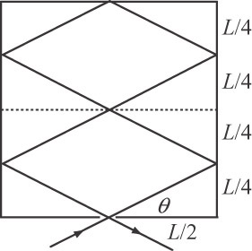 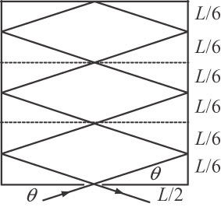

**ANS. FIG. P34.50 (a) ANS. FIG. P34.50 (b) ANS. FIG. P34.50 (c)**

(b) Because the path of the beam is symmetric about a horizontal lines passing through the points where the beam reflects off a side mirror, we can divide the square enclosure into vertically stacked rectangular areas, each a mirror image of the one below. In each, the ray passes upward through the bottom center of the rectangle and exits at its top center until it reflects off the top mirror, then the ray passes back downward through each center until it exits the enclosure. The pattern of the ray’s path is repeated in each rectangle. If the enclosure is divided into *n* rectangles, the height of each rectangle is *L*/*n*, and the beam strikes a side mirror at height *L*/2*n* within each rectangle. Therefore, the angle of entry at the opening is



The cases for *n* = 2 and 3 are shown in ANS. FIG. 34.50(b) and (c) above.



P34.51 (a) We see the Sun moving from east to west across the sky. Its angular speed is



The direction of sunlight crossing the cell from the window changes at this rate, moving on the opposite wall at speed



(b) The mirror folds into the cell the motion that would occur in a room twice as wide:



(c), (d) As the Sun moves southward and upward at 50.0°, we may regard the corner of the window as fixed, and both patches of light move 

**Challenge Problems**

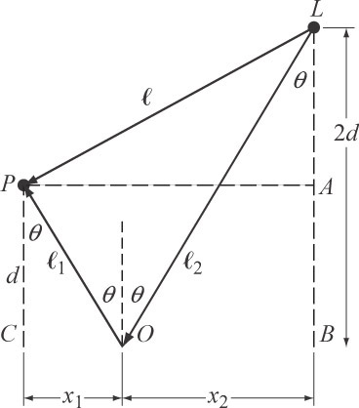

**ANS. FIG. P34.52**

P34.52 The geometry of the situation is shown in ANS. FIG. P34.52, where *P* is the person and *L* is the lightbulb.

We have used the law of reflection to claim that the angles on either side of the dashed line at *O* are equal. From triangle *OPC*, we see that



which can be rearranged to give

  **[1]**

Similarly, from triangle *OLB*,



which can be rearranged to give

 **[2]**

Let *n* = 3.10 from the problem statement. The condition given in the problem is expressed as

 **[3]**

Substitute for  and  from equations [1] and [2]:

 **[4]**

From triangle *APL*, apply the Pythagorean theorem:



Substitute for *x*1 and *x*2 from equations [1] and [2]:



Substitute from equation [3]:

 **[5]**

Eliminate  between equations [4] and [5]:



Simplify this expression:



If we now substitute *n* = 3.10, we see that there is no real solution for sin *θ*. Therefore, it is impossible for the distances to be in this relationship. The largest value that *n* can have is 3.00, which leads to an incident angle of 0°.

In fact, we could have solved this problem more elegantly (and quickly!) by realizing that the largest ratio of distances would be obtained by bringing the person and the lightbulb as close together as possible given the condition on their distances from the mirror. This would be done by aligning them both above *O* in the figure so that the light strikes the mirror at normal incidence. Then, the person and lightbulb are separated by a distance *d*, and the light travels a distance 3*d*. This gives a maximum ratio of 3.00 and we see that a ratio of 3.10 is impossible.

**P34.53** (a) Calling the angle between the dashed line in Figure P34.53 and the reflected laser beam *θ*, we see that



Differentiate with respect to time to find the speed of the laser spot on the wall:

 **[1]**

From Figure P34.53, we see that

 **[2]**

Because the incident ray is stationary, as the mirror turns through angle *φ*, its normal rotates through angle *φ*, so the angle of incidence increases by *φ* as does the angle of reflection. Therefore, the reflected ray rotates through 2*φ*. As a consequence, the angular speed of the reflected ray is twice that of the mirror:

 **[3]**

Substitute equations [2] and [3] into equation [1]:



(b) The variable in this expression is *x*, so we can minimize the speed by setting *x* = 0.

(c) Let *x* = 0 in the expression for *v*:



(d) The maximum speed occurs when the reflected laser beam arrives at a corner of the room, where *x* = *L*/2:



(e) Between the minimum and maximum speed, the reflected laser beam rotates through *π*/4 radians, so the mirror rotates through *π*/8 radians. Therefore,



**P34.54** (a) In the textbook Figure P34.54, we have  and . The speeds in the two media are *v*1 = *c*/*n*1 and *v*2 = *c*/*n*2 so the travel time for the light from *P* to *Q* is indeed



(b) Now  is the requirement for minimal travel time, which simplifies to



(c) Now  and , so we have .

**P34.55** In ANS. FIG. P34.55, a ray travels along path *AM* from point *A* to the mirror, reflects and travels along path *MB* from the mirror to point *B*. Point *A* is a vertical distance *a* above the mirror, and point *B* is a vertical distance *b* above the mirror. Points *A* and *B* are a horizontal distance *d* apart. The ray strikes the mirror at point *M* which is a horizontal distance *x* from point *A*. The angle of incidence is  and the angle of reflection is .

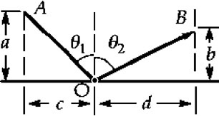

**ANS. FIG. P34.55**

We have  and . The travel time for the light from *A* to *B* is



We require a minimal travel time, so



which simplifies to



This expression is equivalent to



**P34.56** (a) Assume the viewer is far away to the right. In ANS. Fig. P34.56 (a), a ray directed toward the viewer comes tangentially from the edge of the glowing sphere and emerges from the atmosphere at angle . The apparent radius of the glowing sphere is *R*3 as shown. For the figure, we see that



Then,



and



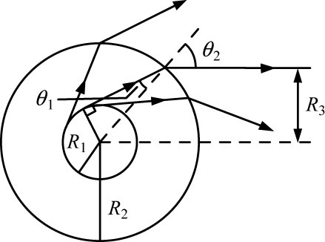

**ANS. FIG. P34.56 (a)**

(b) If a ray is to come tangentially from the edge of the glowing sphere and emerge from the atmosphere, the incident angle  must be less than the critical angle,  Then,



and



This is not so for the case we consider here.

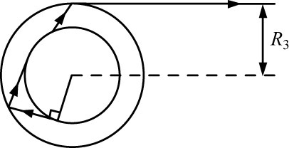

**ANS. FIG. P34.56 (b)**

Thus, the ray considered in part (a) undergoes total internal reflection. In this case a ray traveling toward the viewer must emerge tangentially from the atmosphere, as shown in ANS. Fig. P34.56(b), so the apparent radius of the glowing sphere is the same as the radius of the atmosphere: .

\***P34.57** Define  as the transmission coefficient for one encounter with an interface. For diamond and air, it is 0.828, as in Problem P34.38. As shown in ANS. FIG. P34.57, the total amount transmitted is



We have  so the total transmission is



To sum this series, define



Note that  and



Then,



The overall transmission is then 



**ANS. FIG. P34.57**

|  |
| --- |
| **ANSWERS TO QUICK-QUIZZES** |

**1.** (d)

**2.** Beams ➁ and ➃ are reflected; beams ➂ and ➄ are

refracted.

**3.** (c)

**4.** (c)

**5. (i)** (b) **(ii)** (b)

|  |
| --- |
| **ANSWERS TO EVEN-NUMBERED PROBLEMS** |

P34.2 (a) 3.00 × 108 m/s; (b) The sizes of the objects need to be taken into account. Otherwise the answer would be too large by 2%.

P34.4 (a) See P34.4 (a) for full explanation; (b) Now *CBE* = *φ* is the angle of incidence of the vertical light beam. Its angle of reflection is also *φ*. The angle between the vertical incident beam and the reflected beam is 2*φ*; (c) *φ* = 0.055 7°

P34.6 

P34.8 (a) See P34.8 (a) for full explanation; (b) See P34.8 (b) for full explanation.

P34.10 ; ; 

P34.12 (a) 78.3°; (b) 2.56 m; (c) 9.72°; (d) 442 nm; (e) The light wave slows down as it moves from air to water, but the sound wave speeds up by a larger factor. The light wave bends toward the normal and its wavelength shortens, but the sound wave bends away from the normal and its wavelength increases.

P34.14 (a) , , , ; (b) ,

**P34.16** (a) Yes, if the angle of incidence is 58.9°; (b) No. Both the reduction in speed and the bending toward the normal reduce the component of velocity parallel to the interface. This component cannot remain constant for a nonzero angle of incidence.

P34.18 (a) See P34.18(a) for full explanation; (b) 37.2°; (c) 37.3°; (d) 37.3°

P34.20 (a)  (b) 4.73 cm; (c) For *n* = 1, *h* = 0. For *n* = 2, *h* = ∞. For   
*n* > 2, *h* has no real solution.

P34.22 (a) See ANS. FIG. P34.22; (b) 42.0°; (c) 63.1°; (d) 26.9°; (e) 107 m

P34.24 

P34.26 (a) See ANS. FIG. P34.26 (a); (b) As the waves move to shallower water, the wave fronts slow down, and those closer to shore slow down more. The rays tend to bend toward the normal of the contour lines; or equivalently, the wave fronts bend to become more nearly parallel to the contour lines; (c) See ANS. FIG. P34.26 (c); (d) We suppose that the headlands are steep underwater, as they are above water. The rays are everywhere perpendicular to the wave fronts of the incoming refracting waves. As shown, because the rays tend to bend toward the normal of the contour lines, the rays bend toward the headlands and deliver more energy per length at the headlands.

P34.28 (a) 24.42°; (b) Because the angle of incidence (34.0°) is greater than the critical angle, the light is totally reflected at *P*; (c) 33.44°; (d) Yes. In this case, the angle of incidence is just larger than the critical angle, so the light ray again undergoes total internal reflection at *P*; (e) clockwise;   
(f) 2.83°

P34.30 (a) See P34.30 (a) for full explanation; (b)  and 

P34.32 (a) angle of incidence: 30.0°, angle of refraction: 18.8°; (b) angle of incidence: 30.0°, angle of refraction: 50.8°; (c) and (d) See TABLE P34.32.

P34.34 See P34.34 for full explanation.

P34.36 81 reflections

P34.38 (a)  (b) 68.5%

P34.40 (a) ; (b) 

P34.42 See P34.42 for full explanation.

P34.44 Consider an insulated box with the imagined one-way mirror forming one face, installed so that 90% of the electromagnetic radiation incident from the outside is transmitted to the inside and only a lower percentage of the electromagnetic waves from the inside make it through to the outside. Suppose the interior and exterior of the box are originally at the same temperature. Objects within and without are radiating and absorbing electromagnetic waves. They would all maintain constant temperature if the box had an open window. With the glass letting more energy in than out, the interior of the box will rise in temperature. But this is impossible, according to Clausius’s statement of the second law. This reduction to a contradiction proves that it is impossible for the one-way mirror to exist.

P34.46 (a) The optical day is longer; (b) 164 s

P34.48 (a)  (b) Index of refraction for cubic zirconia is too large to allow any refraction at the second surface.

P34.50 (a) 45.0°; (b) Yes. The ray will exit if it enters at an angle *θ* that satisfies the condition  where *n* = 1, 2, 3, …

P34.52 The person and lightbulb are separated by a distance *d*, and the light travels at a distance 3*d*. This gives a maximum ratio of 3.00, and we see that a ratio of 3.10 is impossible.

P34.54 (a–c) See P34.54 for full explanations.

P34.56 (a) *R*3 = *nR*1; (b) *R*3 = *R*2